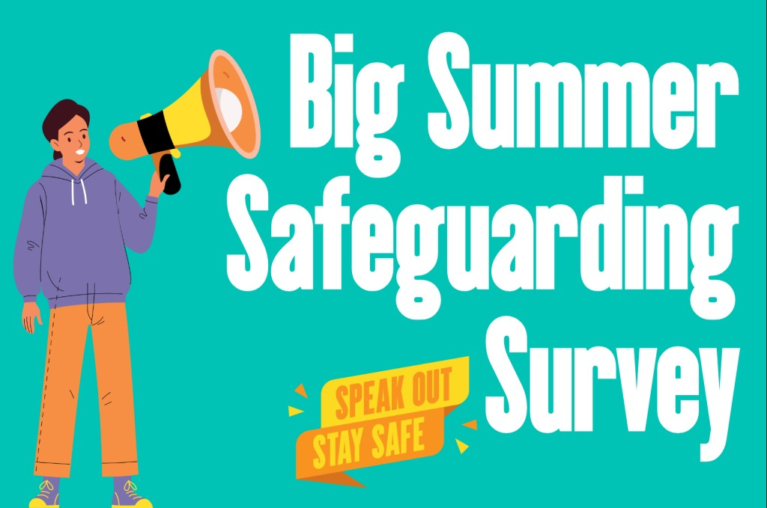

Your voice matters — please help us shape a safer Church.

A MESSAGE FROM THE BISHOP OF CHESTER, MARK TANNER

Dear

Thank you for all that you are doing to make the churches and groups of this diocese as safe as we can be.

As part of a Church of England-wide initiative, we are participating in an independent safeguarding audit. This is a fantastic way to understand how well our diocese and cathedral are doing in creating environments where everyone feels safe, valued, and respected, and to learn how we can improve our practice for the good of all.

This process began earlier this month and will be continuing over the summer. It will conclude with in-person visits from the INEQE Safeguarding Group in early November. We expect to receive their reports and observations early in 2026.

The audit offers a valuable opportunity for us to reflect, learn, and grow… and for that we need your help!

Have your say this summer

We’re inviting everyone in the diocese to take part in a confidential and anonymous online survey. The team is calling this ‘The Big Summer Safeguarding Survey’ and we’ll be sending tools to Parish Safeguarding Officers and Clergy to promote shortly, with reminders over the coming weeks.

This is your chance to share your honest thoughts: to celebrate what’s working well and highlight where we can do better. Whether you’ve had positive experiences or see areas for improvement, your insight is essential. The more voices we hear, the better we can serve and support everyone in our community here in the Diocese of Chester.

Take the survey now: https://ineqe.com/churchofengland/chester/

Let’s work together to build a Church where everyone feels safe, supported, and heard. Thank you for being part of this important journey.

This comes with my thanks and prayers

+Mark

The Rt Revd Dr Mark Tanner
Bishop of Chester

A MESSAGE FROM JANE PLEACE, DIOCESAN SECRETARY AND CHIEF EXECUTIVE

Dear

It’s my hope and prayer that every church and meeting place across Chester diocese is safe and welcoming to all who visit – whether they come once or often. We have a hugely valuable opportunity this year to listen and learn how we can all improve. That starts with listening to you!

You have until Wednesday 3rd September at 11.30pm to complete the survey and responses will go directly to INEQE, not to the Church of England. As Bishop Mark says, we do want everyone to take part. We’re calling it BIG because we want it to reach as many people as possible, far and wide across our parishes. It’s a quick and simple questionnaire that should take around ten minutes to complete.

We want to reach families who access our activities – there’s a special section for those under 18, as well as adults. And it’s not just those in leadership roles, we welcome the views of those who take part in our playgroups, church choirs, bellringers, gardeners … so you’ll be hearing a lot about this over the coming weeks.

When you click on the link, you’ll see several options to choose from which will give you a tailormade set of questions that best suit your own position. If you have several roles, just pick the one that feels most appropriate. You only need to complete one survey.

Here are the answers to some frequently asked questions:

Who is this being sent to? Who should complete the survey?

- The Diocesan Board of Finance, Diocesan Board of Education and Office of the Bishop Workforce
Including all staff or volunteers of these entities and Diocesan Synod.

- The Parish Workforce
Including, for example, clergy, parish staff, volunteers or bell ringers.

- The Parish Community
Including, for example, parishioner, worshipper, or an attendee of another activity at the parish.

- Victims and Survivors
If you are a victim/survivor of church-related abuse, we deeply value your input and insight into current Church of England safeguarding practices.

- Child or Young Person
If you are under 18, tell us about your experiences and what you want to change. However, if you are under the age of 13 then please do so with the help of a parent / guardian.

- The Cathedral Worshipping Community
Including those who visit, attend services or worship at the Cathedral.

- The Cathedral Workforce
Including, for example, the Chapter, clergy, staff, volunteers, choristers, or bell ringers.

How long will it take?

10 minutes

Can/should I send it on to others?
Yes, please do send the link on to others.

I have several roles within the Diocese, what should I do?
Answer it from the role that takes up most of your time or is most central to your work within the Diocese.

I don’t know which survey to complete

When you click on the link, there are different options. The descriptors above should give clarity.

Who will see my answers?
Just the INEQE Safeguarding Group. This is an anonymised survey and completely confidential.

Will anyone follow up with me afterwards?
No

Can I change my answers?

Yes, you can change your answers up to the point of submitting the survey.

Take the survey now: https://ineqe.com/churchofengland/chester/

Thank you for being part of this important piece of work.

Jane Pleace
Diocesan Secretary and Chief Executive Officer

